Motion to Approve FY20 Massachusetts Community Development Block Grant Application
WHEREAS, The Board of Directors of the Marlborough Community Development Authority votes to authorize the MCDA to submit a FY2020 Massachusetts Community Development Block Grant application to the Massachusetts Department of Housing and Community Development in the amount not to exceed $800,000.00 for a housing rehabilitation program, repairs to the roof of 240-250 Main Street, infrastructure improvements and a social service program with the MetroWest Boys & Girls Club or any combination thereof.
THEREFORE, the MCDA is requesting a Motion to Approve FY2020 Massachusetts Community Development Block Grant Application.
MCDA Members Present: MCDA Members Absent: (9
Signatures of MCDA Members Approving this MO ion:
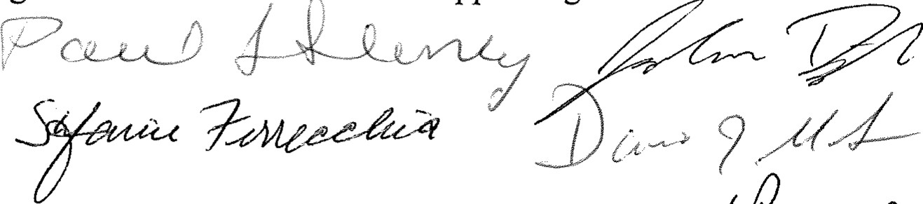
Date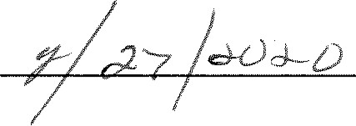
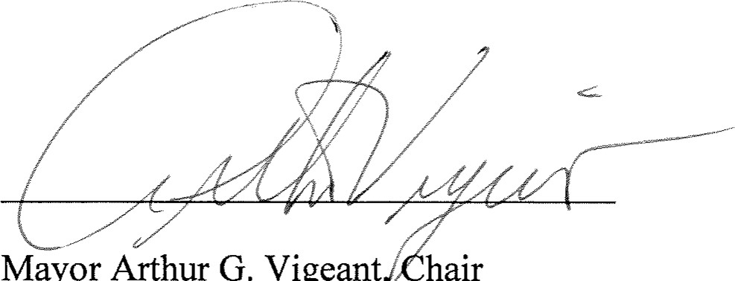
Mayor Arthur G. Vigeant hair
Marlborough Comm. Development Authority

Vote Total: Yes 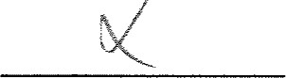 No

