Motion to Approve Federal & State Contracts with Fenton, Ewald & Associates
WHEREAS, Marlborough Community Development Authority (MCDA) was under contract with Fenton, Ewald & Associates for accounting services for FYE 6/2017 through 6/2019.
WHEREAS, MCDA is satisfied with the services provided by Fenton, Ewald & Associates and wants to continue this relationship
THEREFORE, at a regular scheduled meeting of the MCDA Board held on Thursday, February 27th' 2020, a vote was taken to approve the Federal and State contracts for the period of July 1, 2019 through June 30, 2020. Contracts attached.
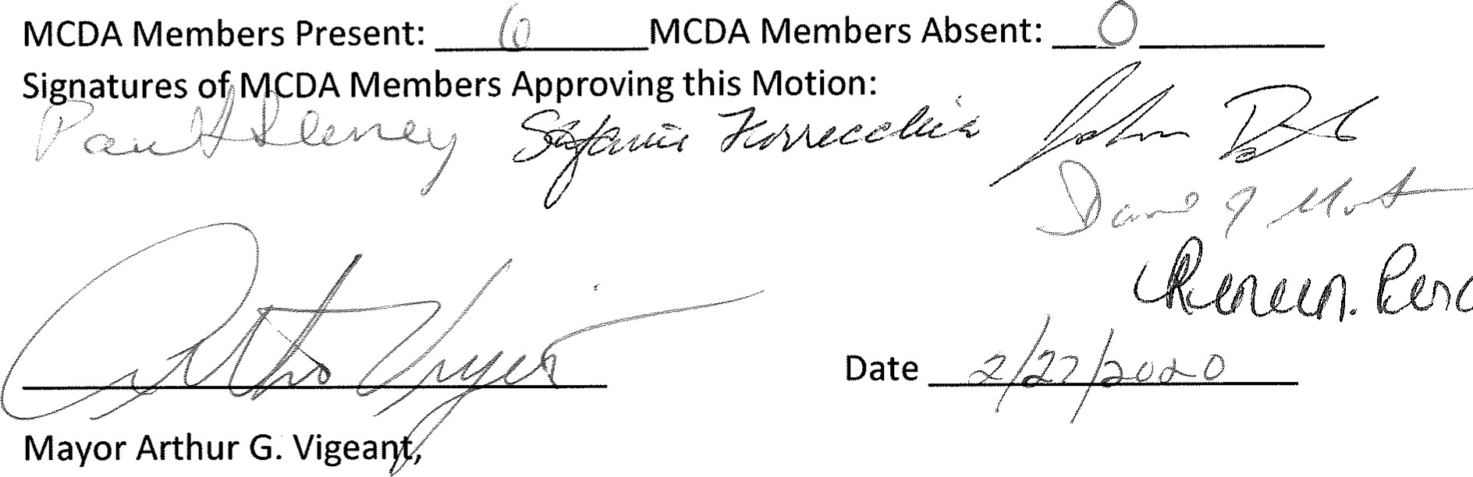etoC&CQO
Chair
of
MCDA

