Motion to Approve Capital Improvement Plan

WHEREAS, Marlborough Community Development Authority establishes a five (5) year Capital Improvement Plan (CIP), of which all major projects, renovations and improvements planned between 2021 and 2025 are outlined. This capital improvement plan is in compliance with the guidelines established by the Massachusetts Department of Housing and Community Development (DHCD).

WHEREAS, the Capital Improvement Plan for 2021-2025 shows complete distribution of funds that have been awarded to the MCDA. The plan distributes the formula funding funds equally and appropriately based on which properties are expected to be renovated, and which are expected to be repaired. The CIP outlines, specifically, the projects that will be occurring within the next five (5) years at each of the MCDA's state elderly properties; 29 Pleasant Street, 397 Bolton Street, and 240 Main Street, as well as our housing for people with mental disabilities on 20 Front Street.

THEREFORE, this capital improvement plan shall be effective for all projects at MCDA's three (3) 667 properties and one (1) 689 property, beginning July 1, 2020 until 2025.

MCDA Members Present: (J MCDA Members Absent: C)

Signatures of MCDA Members Approving this Motion:

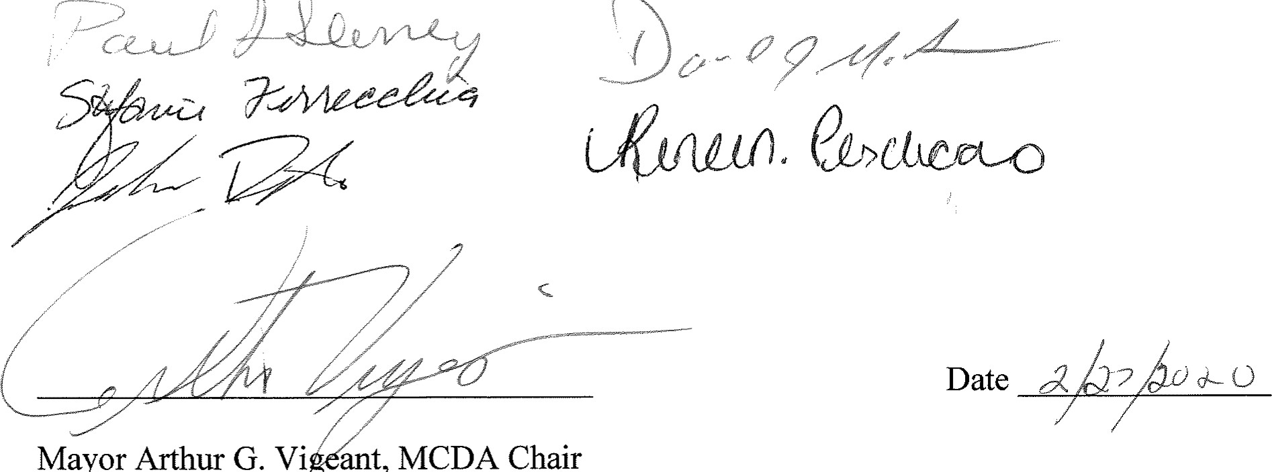

Mayor

Arthur

G.

Vi

ant,

MCDA

Chair

Capital Improvement Plan 1 July 1, 2020