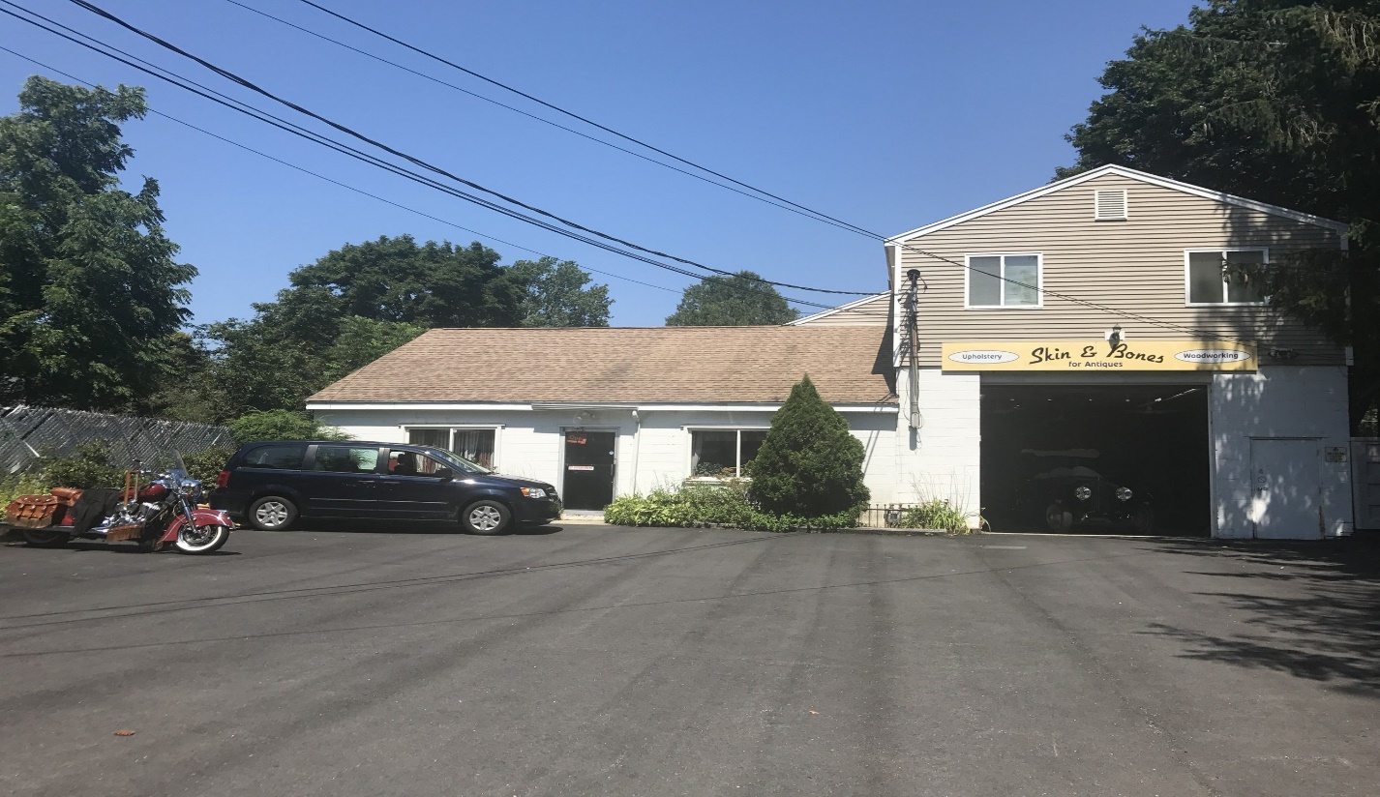

All Fur Love

Business Overview
All Fur Love is a grooming salon and doggie daycare in Medway Ma. We aim to provide excellent pet care at a reasonable price. Because dogs are part of each home’s family, they deserve the best treatment available. We maintain a safe and dog-friendly environment that assures our clients that their pets are in good hands whenever they leave them at our salon or daycare. We are interested in opening a second location at 75 Lincoln St in Marlborough. This location would be fully dedicated to grooming only. We are a small-scale business that loves to be involved in the community.

Services offered
All Fur Love will be providing dog and cat grooming services. These services will include grooming for all breeds and sizes.
Our services are provided in a timely manner unlike most salons. All our clients' pets are groomed by appointment. This is so their pets can be back home within two hours. We also accept in walk in clients for quick services such as: Nail trims, ear cleaning, face trims. All Fur love also caters to special need and elderly pets. The way we operate really sets us apart from other salons.
Exterior
We plan to landscape the parking lot adding arborvitaes along the sides to create a more private area. The building will have no major renovations.
Painting and cleaning around the building only. The current street sign will remain the same just adding our logo. The current sign on the building will also remain the same size just updating with our logo.

Interior
The interior of the building will remain as an open concept. A small reception office in front. Creating a grooming area in the back of the building. We will be adding new floors and paint inside as well. The upstairs will remain as the two apartments. (67A/B Lincoln st)

Parking
75 Lincoln St has 16 parking spots available. Two would be dedicated to employees. Having two rentals at this location, four spots would be for tenants. Leaving ten available spots open for customers to drop or pick up their pet. No street parking would be necessary.
Hours
We would operate Monday through Friday 8am to 5pm. Saturday hours would be 8am to 3pm. Sundays are always closed. All Major holidays and the day after would also be closed.

Management Team
All Fur Love’s most valuable asset is the expertise and experience of its owners Marquel and Divino, they have been in the pet care business for close to twenty years each.
Having this business Partership has many positive points. We are an excellent team that brings many qualities together. Divino’s experience and knowledge has made it possible for him to train each of our groomers. Marquel’s love for animals and expectational customer service skills keeps clients coming back. Each location would have an owner working daily to ensure clients receive the proper care.

Success Factors
All Fur Love is uniquely qualified to succeed due to the following reasons:
- This location is in a growing area where customers are in need of dog grooming services.
- The management team has a track record of success in the dog grooming services business.
- The local area is currently underserved and in need of quality pet care.
- Divino and his family have been Marlborough residents for close to twenty years. He already has a small word of mouth clientele that travels to our Medway location.

