City of Marlborough
Licensing Board
140 Main Street, Lower Level
Marlborough, MA 01752
(508) 460-3751 FAX (508) 460-3625

Minutes of the Special Licensing Board Meeting Held Thursday, November 15, 2018
at 7:30 pm, City Hall, 1st floor, Council Committee Room.

Attending: Walter Bonin, Chairman; David Bouvier, Member; Tina Nolin, Clerk
Absent: Gregory Mitrakas, Member;

Meeting called to order by Walter Bonin, Chairman at 7:30 PM

New Business

- New Farmers Series Pouring License – Flying Dreams Brewery, 277 Main St.
David Richardson, owner/applicant

Public meeting opened at 7:35

Dave Richardson spoke briefly about the establishment

There were not positive or negative comments from the public.

The public meeting was closed at 7:46

Chairman Bonin recommended adding to the application that “Samples of 2
Do not constitute a sale.”

Member Bouvier motioned to approve the Pouring License, Chairman Bonin seconded, the motion; Board vote: 2 – 0 to approve the license.

Respectfully submitted,
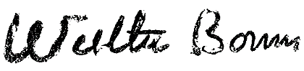

Walter Bonin, Chairman

